# REING OF HUMANAE

## Summary

The world of Reign of Humanæ began with only one intelligent race, the Humanae. As time passed, the Humanae divided into four distinct races: Humans, Elves, Dwarfs, and Demons. Each race had unique characteristics and abilities that made them stand out from the others.

The Humans were known for their adaptability and large communities. They had the ability to learn things 15% faster than other races and had a 10% resistance to cold.

The Elves were a reclusive race that lived in small communities within forests. They had a deep connection with nature and had the ability to learn nature magic and agility skills 20% faster than other races. Creatures in the forest would not attack them unless provoked.

The Dwarfs lived in caverns and did not like other races, particularly the Elves. They were known for their advanced technology and had the ability to make items 25% more powerful. They were also 10% faster at mining and could learn strength skills 20% faster than other races. However, they struggled with magic, finding it 20% harder to learn.

The Demons preferred warm climates and did not like other races. They had a natural ability to learn fire magic 25% faster than other races and had a 50% resistance to fire. However, they found it 20% harder to learn agility and strength skills.

As the races interacted, alliances and rivalries were formed. Some races formed alliances to gain an advantage in the world, while others waged wars against each other. The world of Reign of Humanæ was full of adventure and excitement as the races battled for supremacy in a world filled with magic and technology.

## The Races

The ancient realm of Humanae flourished with a unity that transcended time. The Humanae, an intelligent race gifted with a collective consciousness, thrived in harmony for centuries. However, as the eons unfolded, the essence of Humanae splintered into distinct entities, giving rise to the Humans, Elves, Dwarfs, and Demons.

**Humans:** Dwelling in vast, bustling communities, Humans adapted to their surroundings with unparalleled ease. Their minds were attuned to accelerated learning, granting them a 15% advantage in getting knowledge. With a natural resistance to the biting cold, Humans carved their mark on the world through exploration and innovation.

**Elves:** Nestled within the heart of ancient forests, the Elves embraced a secluded existence. Their spirits intertwined with nature, granting them a profound connection. Proficient in the arts of nature magic and blessed with agile prowess, Elves could navigate the dense woodlands effortlessly. Creatures of the forest recognized the Elves' harmony with nature, only retaliating if provoked.

**Dwarfs:** Burrowed deep within subterranean caverns, the Dwarfs forged a civilization fueled by advanced technology. While their craftsmanship allowed them to create items of unparalleled strength, the Dwarfs harbored a disdain for other races, particularly the Elves. Swift miners and masters of strength, Dwarfs faced a struggle with the arcane, finding magic elusive and challenging to understand.

**Demons:** Thriving in the warmth of exotic landscapes, the Demons reveled in their fiery domains. Endowed with an innate affinity for fire magic and an enviable 50% resistance to flames, Demons shunned interaction with other races. However, their pursuit of physical and magical prowess made agility and strength skills arduous to get.

As the races unfolded into existence, alliances and animosities permeated the world. Some sought unity, forming alliances to harness the diverse strengths of each race. Others, driven by ancient grudges or thirst for power, waged wars that echoed through the annals of history. The world of Reign of Humanæ became an epic canvas where magic and technology collided, shaping the destinies of these disparate races. In every alliance forged and every war waged, the pulse of adventure and excitement echoed across a realm teeming with untold mysteries and possibilities.

## Dawn of the Age of Splendors

In the closing chapters of the War of the Races, a conflict that had raged across the realms for centuries, a wearied world yearned for respite. It was in the year 897 of the Age of Strife that the warring factions, exhausted by the bloodshed and loss, reluctantly sheathed their weapons. The leaders of the Humans, Elves, Dwarfs, and Demons met on the neutral grounds of the Sacred Conclave to negotiate an end to the strife that had defined generations.

Amidst the ancient ruins of the Conclave, a historic accord known as the Pact of Unity was forged. Representatives from each race, scarred and weary, pledged to set aside their grievances and forge an era of peace. The Pact delineated the borders of each realm, set up diplomatic channels, and promised collaboration in the face of common threats.

As the embers of war cooled, the denizens of the world cautiously embraced the dawning of the Age of Splendors. The scars of the conflict lingered, but hope blossomed anew. Cities once fortified against invasion now embraced open trade, and the scars of battlefields transformed into fields of growth and renewal.

The once-hostile races began to collaborate on grand endeavors that transcended their individual interests. Human architects worked alongside Elven scholars to construct marvels that blended natural aesthetics with technological innovation. Dwarven artisans, known for their craftsmanship, shared their knowledge with Demonic blacksmiths, forging alliances in the fiery depths of subterranean forges.

In this era of unity, the diverse races discovered the richness that came from embracing their differences. Cultural exchanges flourished, and festivals celebrating the unique traditions of each race became grand spectacles that drew visitors from every corner of the realm. The world was painted with a tapestry of vibrant cultures and shared experiences, binding the races together in an intricate dance of harmony.

The leaders of the Pact of Unity, once adversaries on the battlefield, became ambassadors of peace, fostering goodwill and understanding. Councils were set up, where representatives from each race met regularly to address concerns and ensure that the fragile peace remained unbroken.

The Age of Splendors became a time of enlightenment, innovation, and artistic renaissance. Magical academies flourished, blending the arcane knowledge of Elves with the pragmatic applications of Dwarven technology. Trade routes crisscrossed the lands, connecting once-isolated regions in a network of prosperity.

Yet, the echoes of the War of the Races lingered in the collective memory of the world, serving as a reminder of the fragility of peace. As the Age of Splendors unfolded, the inhabitants of the realm worked diligently to build a legacy that would endure—a legacy forged in unity, understanding, and the shared pursuit of a brighter future.

## The Unraveling Veil

In the year 1178 of the Age of Splendors, a renowned human mage named Elara Ardentweaver set out on an ambitious quest to unravel the mysteries of the cosmos. Elara, driven by insatiable curiosity and an unyielding thirst for knowledge, delved into the forbidden realms of interdimensional magic.

In her secluded tower, nestled amidst the towering peaks of the Serathian Mountains, Elara conducted countless experiments to breach the boundaries between worlds. With each incantation and rune etched into ancient tomes, she looked to create a portal that would unveil the secrets of alternate dimensions.

As the ethereal energies coalesced, Elara succeeded in tearing the fabric of reality itself. However, the consequences of her audacious endeavor proved catastrophic. Instead of a controlled gateway to another world, rifts began to materialize unpredictably across the land. Portals manifested in the heart of bustling cities, in dense forests, and atop majestic peaks, defying the laws of magic and physics.

To the horror of the inhabitants of the realm, these portals became conduits for otherworldly beings—ferocious monsters and creatures unknown to the mortal plane. Chaos ensued as the once-peaceful lands were besieged by hordes of fantastical beasts pouring through the unintended tears.

Elara, realizing the magnitude of her unintended calamity, sought redemption. With unwavering determination, she devoted herself to the study of a counter-spell to seal the portals and banish the interlopers back to their realms. The mage's once-towering reputation crumbled as she became an outcast, blamed for the havoc she had unleashed upon the world.

As the portals continued to spawn, Elara's quest for redemption intensified. With each passing day, the world plunged deeper into turmoil, and the once-pristine landscapes bore the scars of interdimensional intrusion. Villages were razed, and cities stood on the brink of collapse.

The year 1182 of the Age of Splendors became synonymous with tragedy, as the land grappled with the consequences of Elara's ill-fated ambition. Tales of the mage who had looked to transcend the boundaries of reality now served as cautionary lore, a reminder of the delicate balance that held the fabric of existence intact. In the shadow of devastation, Elara Ardentweaver fought against time and scorn to mend the veil she had unwittingly torn, hoping to restore peace to a world thrust into chaos by the very magic she had dared to command.

## The Sentinel Accord

In the wake of the unintended interdimensional portals that unleashed a relentless horde of monsters upon the world, the Races of Humanae found themselves in dire need of a solution. Faced with the constant threat of monstrous incursions, leaders from all realms met in an unprecedented alliance, driven by a shared commitment to preserve the hard-fought peace of the Age of Splendors.

The key to their defense lay in a groundbreaking collaboration between the Dwarfs and the Elves. Recognizing the strengths of each race, they forged an agreement known as the Sentinel Accord. The Dwarfs, masters of technology and engineering, would contribute their ingenuity to create formidable defensive structures. The Elves, with their profound connection to magic, would infuse these structures with enchantments to repel and deter the otherworldly invaders.

The Accord gave birth to an array of ingenious devices known as Sentinel Artifacts—towering constructs, runic barriers, and mystical wards strategically placed at key locations where portals manifested. These tools harnessed the power of both Dwarf technology and Elven magic, creating a potent defense against the relentless tide of monsters.

However, the Sentinels were not without their challenges. The interdimensional energies that surged through the portals took a toll on the mechanisms and enchantments, needing constant maintenance. The Dwarven engineers and Elven enchanters worked tirelessly to keep the Sentinels at peak efficiency, but the strain of their efforts was clear.

The Sentinels stood as guardians, vigilant against the encroaching darkness. The realm felt relieved as the onslaught of monsters was slowed, giving the Races time to rebuild and fortify their cities. Trade routes were reestablished, and communities flourished under the watchful eyes of the Sentinel Artifacts.

Yet, the delicate equilibrium between the races and the forces of chaos hung in the balance. The maintenance of the Sentinel Artifacts became a continuous struggle, a testament to the fragility of the peace they safeguarded. As time passed, the wear and tear on the devices grew more pronounced. Failure to repair them on time allowed breaches in the defenses, and the monsters would surge forth once more.

The Sentinels became symbols of resilience and cooperation, but also of the persistent threat that loomed beyond the portals. The Races of Humanae faced an unending cycle: repair the Sentinels to secure peace or risk the resurgence of the monstrous onslaught. In the heart of this struggle, a new generation appeared—Dwarven engineers and Elven enchanters united by a common cause—to ensure that the Sentinel Accord endured, and with it, the fragile peace of the Age of Splendors.

# World Bosses

## Celestial Wyrm, Elyndria:

A majestic dragon adorned with celestial scales, Elyndria soars gracefully through the skies. Peaceful by nature, she only unleashes her devastating breath of starlight upon those who threaten her sacred roost.

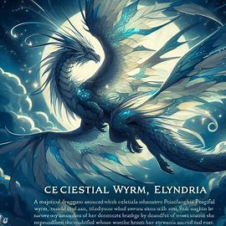

## Golem Tyrant, Ignar Stoneheart:

Crafted from enchanted stones by Dwarven artisans, Ignar Stoneheart is a colossal golem with a heart of molten lava. Though formidable, Ignar stays dormant until provoked, defending the subterranean sanctuaries of his creators.

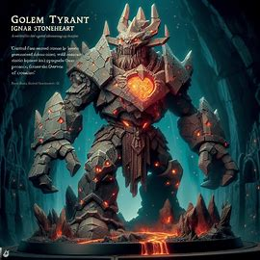

## Sylvan Behemoth, Verdant Groveguard:

A colossal treant covered in vibrant foliage, Verdant Groveguard serves as the protector of ancient Elven forests. He stands dormant among the towering trees, awakening only to defend against those who would harm the sacred groves.

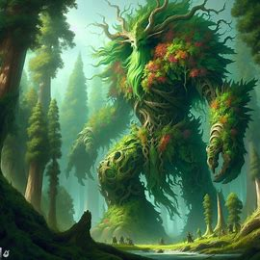

## Storm Serpent, Tempestia the Thundercoil:

Coiling through storm-laden skies, Tempestia commands the fury of thunder and lightning. This benevolent serpentine force only reveals its wrath when the balance of the atmospheric energies is disrupted.

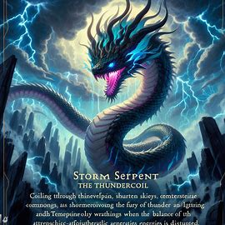

## Infernal Arbiter, Pyrax the Judgmental:

A fiery demon lord, Pyrax judges the intentions of those who approach. His towering presence guards the entrance to the demonic realms, punishing only those who harbor ill will.



## Lunar Gazer, Selene the Moonshadow:

A mystical wolf with fur as silver as the moon, Selene roams the nocturnal landscapes. She is the guardian of Elven dreams, attacking only those who disrupt the peaceful harmony of the night.

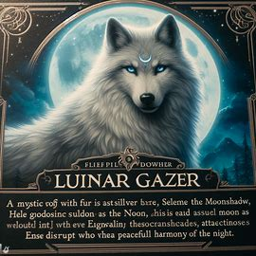

## Aegis Guardian, Thrain the Shieldbearer:

Crafted by Dwarven forges, Thrain is a colossal suit of enchanted armor wielding a massive shield. He stands sentinel at the borders, protecting cities from external threats but staying inert in the absence of danger.

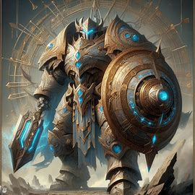

## Abyssal Leviathan, Maridrax the Depthbringer:

Dwelling in the ocean depths, Maridrax is a massive sea serpent surrounded by an aura of dark waters. His immense presence discourages interference with the marine realms, and he only rises to quell disturbances.

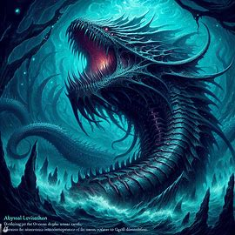

## Celestial Weaver, Arachnia Luminara:

A spider-like entity with ethereal silk, Arachnia weaves the fabric of starlight. Her intricate webs connect realms, and she defends her domains against those who would unravel the cosmic threads.

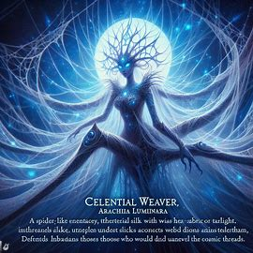

## Ethereal Whisperer, Zephyros the Zephyr Caller:

A serene and ethereal being, Zephyros controls the winds and the breath of life. Though not aggressive, he intervenes when the elemental balance of the skies is disrupted.

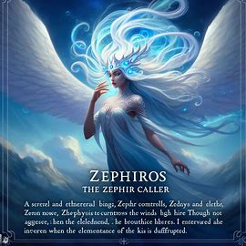

## Molten Monarch, Magmara the Emberqueen:

A fearsome dragon made of molten lava, Magmara guards the volcanic heart of the world. She stays dormant unless the sacred molten realms are threatened.

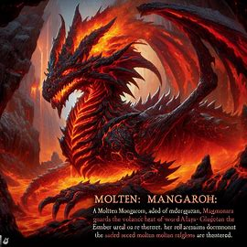

## Lunar Sage, Nocturna the Nightbinder:

A wise owl with eyes that mirror the cosmos, Nocturna guards the secrets of the night. She is a neutral observer, intervening only to keep the delicate equilibrium between light and darkness.

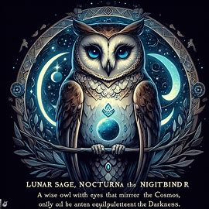

# Mechanics

## The King or Queen

Each kingdom's ruler starts as an NPC. Once every three months, a tournament is held to challenge the reigning king. The tournament winner receives a reward and has the choice to challenge the king or not. If a player defeats the king, they become the new ruler of the kingdom.

The king has the authority to declare war on other kingdoms, set import and export taxes for items between realms, and create special quests for players within the realm. The king also has control over guard behavior, deciding whether other races are allowed entry into the city and deciding the response to Player Killers (PKs) - players who kill others from the same or different realms during peacetime.

If a player who holds the position of king doesn't log in for 7 days, the NPC king will automatically assume the role. NPC kings always support peace between realms unless a player king declares war.

## The Guards

The guards in each kingdom are distinct. In the Demon realm, trained hellhounds serve as guards. In the Human realm, summoned guards lacking faces protect the kingdom. The Elven realm relies on ents and a few fairies as guardians, with the forest itself safeguarding the Elves. Dwarves deploy mechanical guards—robotic units—to protect their kingdom.

## Item Crafting

Each race can craft distinct items. However, a master blacksmith who is a player can sell crafting instructions of their race to players from other races. Crafting each item requires specific materials.

## Magic and Abilities

Skills, item handling, and forging are enhanced as players use them. For example, a player who often uses a bow will improve their archery skill over time. In the skill tree, players can choose advantages as they reach specific skill levels. The same progression system applies to magic, forging, and other abilities.

Magic can be channeled to enhance its effect. Each second of channeling consumes more mana, and as a player's affinity with that magic type increases, both mana consumption and the channeling time to reach the maximum are reduced.